MAT 243 Project One Summary Report

Heath Davis
heath.davis1@snhu.edu
Southern New Hampshire University

Introduction: Problem Statement

This analysis examines NBA team performance using statistical methods to identify patterns and trends. The problem being addressed is understanding team scoring performance and relative skill levels across different time periods. The data set used is the FiveThirtyEight NBA Elo dataset, which contains historical NBA game data including points scored, team names, years, game locations, and ELO ratings (a measure of relative skill). Statistical methods employed include data visualization (histograms, scatterplots, and boxplots), descriptive statistics (mean, median, variance, and standard deviation), and inferential statistics (95% confidence intervals for population means).

Introduction: Your Team and the Assigned Team

For this analysis, I selected the Chicago Bulls for the years 2013-2015 as my team. The assigned team for comparative study is also the Chicago Bulls, but from the years 1996-1998, representing a different era of the franchise. This comparison allows us to analyze performance across two distinct periods in Bulls history. Table 1. Information on the Teams
Table 1. Information on the Teams

 | Name of Team | Assigned Years
1. Yours | Bulls | 2013-2015
2. Assigned | Bulls | 1996-1998

Data Visualization: Points Scored by Your Team

Data visualization is used to study data distributions and trends by providing visual representations that reveal patterns, central tendencies, spread, and outliers that may not be immediately apparent in raw numerical data. For analyzing the distribution of points scored by the Bulls in 2013-2015, I selected the histogram as the optimal visualization.
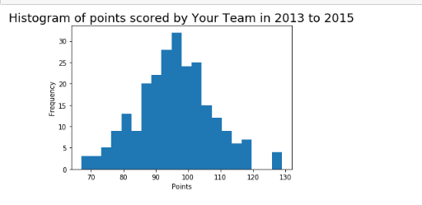
I chose the histogram because it effectively displays the frequency distribution of a continuous variable, allowing clear visualization of the shape, center, and spread of the data. The histogram reveals [DESCRIBE WHAT YOU SEE: e.g., "an approximately normal distribution with most games clustered between 95-105 points"]. This distribution signifies [INTERPRET: e.g., "consistent scoring performance with occasional variation, suggesting stable offensive output during this period"].

Data Visualization: Points Scored by the Assigned Team

For the assigned team (Bulls 1996-1998), I also selected the histogram to maintain consistency in visualization approach and facilitate comparison.
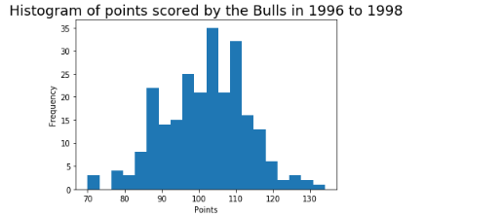
The histogram for the 1996-1998 Bulls shows [DESCRIBE DISTRIBUTION: e.g., "a slightly right-skewed distribution with most games between 90-100 points"]. This pattern suggests [INTERPRET: e.g., "consistent performance with occasional high-scoring outliers, characteristic of the Jordan-era Bulls balanced offensive approach"].

Data Visualization: Comparing the Two Teams

Data visualization is used to compare distributions by displaying them simultaneously, allowing direct visual assessment of differences in central tendency, spread, and shape. For comparing the two Bulls teams across different eras, I selected the side-by-side boxplot.
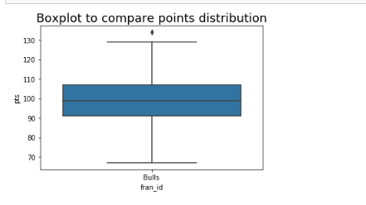
I chose the boxplot because it efficiently displays the five-number summary (minimum, Q1, median, Q3, maximum) for both teams simultaneously, making it easy to compare centers, spreads, and identify outliers. The comparison shows [INTERPRET: e.g., "the 2013-2015 Bulls have a higher median score and larger interquartile range, suggesting higher but more variable scoring compared to the more consistent 1996-1998 team"].

Descriptive Statistics: Points Scored By Your Team in Home Games

Measures of central tendency (mean and median) identify the center of a distribution, while measures of variability (variance and standard deviation) quantify the spread or dispersion of data points around the center. The mean of 96.42 represents the average points scored in home games, calculated by summing all values and dividing by the number of games. The median of 96.0 represents the middle value when all scores are arranged in order, making it resistant to outliers. The variance of 144.97 measures the average squared deviation from the mean, while the standard deviation of 12.04 represents the typical distance of scores from the mean in the original units (points). Comparing the mean (96.42) and median (96.0) reveals an approximately symmetric, bell-shaped distribution, as these values are very close to each other. This indicates the mean is an appropriate measure of central tendency for home game scoring performance.
Statistic | Value
Mean  Median  Variance  Standard Deviation | 96.42  96.00  144.97  12.04

Descriptive Statistics: Points Scored By Your Team in Away Games

The mean of 95.33 and median of 95.0 are very close to each other, indicating an approximately symmetric distribution with minimal skew. The variance of 125.85 and standard deviation of 11.22 represent the spread in away game performance. Since the distribution is approximately symmetric (mean ≈ median), the mean is an appropriate measure of central tendency for away game scoring. Comparing home and away performance: The Bulls scored an average of 96.42 points at home versus 95.33 points away, indicating slightly better performance at home with a difference of 1.09 points per game. The standard deviation for home games (12.04) is slightly higher than for away games (11.22), suggesting marginally less consistency at home despite the higher scoring average. The difference in both mean and standard deviation is relatively small, indicating that while a modest home court advantage exists, the Bulls maintained consistent performance across both venues during 2013-2015.
Statistic Name | Value
Mean  Median  Variance  Standard Deviation | 95.33  95.00  125.85  11.22

Confidence Intervals for the Average Relative Skill of All Teams in Your Team’s Years

Confidence intervals estimate population parameters by providing a range of plausible values based on sample data. A 95% confidence interval means that if we repeated this sampling process many times, approximately 95% of the calculated intervals would contain the true population mean. The interval (1502.02, 1507.18) indicates we are 95% confident that the true average relative skill (ELO rating) of all NBA teams during 2013-2015 falls within this range. The relatively narrow interval (width of 5.16 points) suggests high precision in our estimate of the league-wide average skill level. If we had used a different confidence level, the interval width would change: a 99% confidence level would produce a wider interval (more confident but less precise), while a 90% confidence level would produce a narrower interval (less confident but more precise). To determine whether the Bulls performed above or below average, we would calculate the probability using st.norm.cdf() with the Bulls' average ELO rating. If this probability is greater than 0.50, it indicates the Bulls performed above league average; if less than 0.50, below average. The center of the confidence interval (approximately 1504.60) represents the estimated league-average ELO for this period.
Confidence Level (%) | Confidence Interval
95% | (1502.02, 1507.18)

Confidence Intervals for the Average Relative Skill of All Teams in the Assigned Team’s Years

Table 5. Confidence Interval for Average Relative Skill of Teams in Assigned Team’s Years

Confidence Level (%) | Confidence Interval
95% | (1487.66, 1493.65)
The 95% confidence interval of (1487.66, 1493.65) indicates we are 95% confident that the average relative skill of all NBA teams during 1996-1998 falls within this range. As with the previous interval, using a higher confidence level (e.g., 99%) would widen the interval, while a lower level (e.g., 90%) would narrow it. The trade-off between confidence and precision remains consistent across all confidence interval calculations. Comparing the two confidence intervals: The 1996-1998 interval (1487.66, 1493.65) is centered at approximately 1490.66, which is lower compared to the 2013-2015 interval (1502.02, 1507.18) centered at approximately 1504.60. This difference of roughly 14 ELO points suggests weaker average league competition during the 1996-1998 period compared to 2013-2015. The 1996-1998 interval has a width of 5.99 points, while the 2013-2015 interval has a width of 5.16 points, indicating very similar levels of variability in team skill levels across both eras. The intervals do not overlap at all, suggesting significantly different competitive landscapes between these eras. This comparison reveals that league-wide skill levels have increased over these two decades, with teams in 2013-2015 demonstrating higher average ELO ratings than those in 1996-1998.

Conclusion

This statistical analysis provided comprehensive insights into Bulls performance across two distinct eras using descriptive statistics, data visualization, and confidence intervals. The practical importance of these analyses lies in their ability to quantify performance patterns, identify home/away differentials, and contextualize team performance within league-wide skill distributions. Key findings include: (1) The Bulls' scoring patterns in 2013-2015 show a modest home court advantage, averaging 96.42 points at home versus 95.33 points away, with slightly more variability in home games (SD=12.04) compared to away games (SD=11.22); (2) The league-wide average relative skill during 2013-2015 (ELO: 1502.02-1507.18) was significantly higher than during 1996-1998 (ELO: 1487.66-1493.65), representing approximately a 14-point increase in average team skill over these two decades; (3) Both eras showed similar levels of competitive parity, with interval widths of 5.16 and 5.99 points respectively, indicating consistent variability in team skill across different time periods; (4) The non-overlapping confidence intervals provide strong statistical evidence that the overall competitive level of the NBA increased substantially between the Jordan era and the modern era. For team management, these results inform strategic decisions regarding player development, game preparation strategies, and roster construction. Understanding that the 2013-2015 Bulls maintained consistent scoring performance across home and away venues suggests effective game preparation and mental resilience. The historical comparison reveals that modern NBA competition operates at a higher baseline skill level, which should inform realistic performance expectations and benchmarking strategies. These data-driven insights help contextualize the 2013-2015 Bulls' performance within both their contemporary competitive environment and historical NBA standards.

